Name | SHAFKAT AHMAD KHANDI
Designation | Associate Professor
Contact Address | Division of Veterinary & Animal Husbandry Extension Education,  Faculty of Veterinary Sciences & A.H., R. S. Pura, SKUAST-J, Jammu & Kashmir - 181102
E -mail | shafkatext@gmail.com
Mobile | 7006063441
Professional Experience | 15 years (Teaching, Research and Extension)  (One year and one month as Guest Lecturer/Teaching Assistant)
PG students Guided | Major Advisor:  - Ph.D: 01  - M.V.Sc: 07  Co-Advisor:  - Ph.D: 04  - M.V.Sc: 20
Awards/honours/  scholarships/fellowships | International:  - International Fellowship Award by the Government of Netherlands  - Best Oral Presentation Award at International Buffalo Congress-2019 held at University of Veterinary & Animal Sciences, Lahore-Pakistan  - Attended an International training programme on “Training & Extension” organized by the Government of Netherland w.e.f 05.06.2019 to 06.07.2019.  National :  - Remained Head of the Division two times  - University Merit Scholarship holder at M.V.Sc Level (Scholastic Standards of High order) (Topper).  - University Merit Scholarship holder at Ph.D Level (Scholastic Standards of High Order).  - Budding Extensionst Award-2015  - Farmer Lead Extension Award-2017  - Best Extension Scientist Award-2023  - Best Paper/Poster Presentation Awards: 12 No.s
Publications | More Than 60 Research Articles
No. of books/Manuals/  Monographs | Books: 01  Contributory chapters : 10  Manuals: 04  Monographs: 20
Research Projects | Project Investigator:  - DST: 01  - University funded: 01  Co-Project Investigator:  - Externally funded: 06 (04 Completed & 02 Ongoing)  - University funded: 02 (Completed)
Research interests | - Pastoral/tribal livestock production systems  - Perception in cellular agriculture- cultivated meat  - Socio-economic impact of lumpy skin disease  - Perception about edible insects as a source of protein  - Precision farming/ smart livestock farming  - Adoption and diffusion of scientific animal husbandry practices  - Ethno-veterinary and indigenous technical knowledge
Other achievements | - Represented the State in 10th National Chess Championship held at Jamshedpur.  - Represented the State in TATA STEEL 38th National ‘B’ Chess Championship held at Jamshedpur.  - Represented the State in 45th Junior National Ball Badminton Championship held at Jaipur, Rajasthan.  - Represented the State in 46th Junior National Ball Badminton Championship held at Bhilai, M.P.  - Represented the SKUAST-J in two events (Volley Ball and 100m Running) at Inter-university Competitions held at Parbhani, Maharashtra.  - Represented the SKUAST-J in Volley Ball at Inter-university Competitions held at Bareily, U.P.

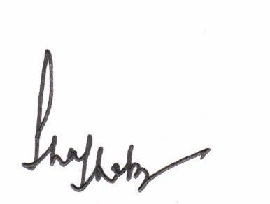
(Shafkat Ahmad Khandi)

